MAIN CHARACTERS

CILLIAN CORLESS – DANNY
JADE HOGAN - SANDY
ZACH O’REILLY - SONNY
EMMA NOLAN – PATTY SIMCOX
FINNIAN KING - DOODY
AOIBHIN COLLINS - RIZZO
DAN CAULFIELD - KENICKIE
AMY WYNNE – CHA CHA DIGREGORIO
HASSAN AL NAGAR – JOHNNY CASINO
MEG DOWNES - JAN
SEAN MURPHY – VINCE VONTAINE
MAEBH STEBBING - MARTY
MOLLY FAHY - FRENCHIE
RACHEL THORNTON – PRINCIPLE MC GEE
FERGUS WHYTE - EUGENE
BEN JONES - ROGER

CAST
The Dance Troop
Siofra Galvin, Bebhinn Howard, L,auren Mc Loughlin, Katie O’Neill, Evie O’Brien, Bill Nolan, Claudia Davis, Eimear White, Larissa Sutton, Ben Flanagan, Ben Jones, Patrick Moxom, James Sexton, Jade Hogan, Emma Nolan, Aoibhin Collins, Jenny Dillon Amy Wynne, Anna Young, Lucy Coller, Eleanor Traynor, Mary Hamilton, Muireann Whelan, Hollie Silke-Fetherston, Lillie Gallagher, Caelinn McDermot, Zach O’Reilly, Daniel Cawlfield.

TY and 5th Years
Anna Blake, Anna Young, Caoimhe Byrne, Trinny Daly, Mary Enright, Caitlin Harley, Emma Brady, Ivanna Dempsey, Caoimhe Brinkley, Sarah Murnane, RUTH MC CORMACK, VICTORIA ALABI, SAM TRAYNOR, JENNY DILLON, ANNMARIE MC CARTHY, LUCY COLLER, CHARLOTTE MOONEY, KANNA KODAMA, JANE MAGEE, JAMES SEXTON, PATRICK MOXOM, AMY WYNNE, MARIONA ROSETT ROSALLES, ELEANOR TRAYNOR, ROISIN HORAN, TEGAN KELLY, HOLLIE SILKE FETHERSTON,MUIREANN WHELAN, ANNA KENNEDY, LILLIE GALLAGHER, MARY HAMILTON, AOIFE KAVANAGH, YASMIN FRIEL, MELISSA SCULLY, AIDAN BOLGER, LEON BARRY CULLEN,CAELINN MC DERMOT, SUZIE TREACY, JAMES LEE

1st and 2nd Years
EVIE O’BRIEN, HOLLY MA DONALDSON, EMMA SEDDON, SIOFRA GALVIN, GRACE FARRELL, ROBYN LAHART MC MAHON, MOYA FLYNN, BILL NOLAN, BEBHINN HOWARD, NIAMH ASPINALL, BRIAN HALL, KATIE PRENDERGAST, KATIE O’NEILL, SHANE TREACY, MEITONG LUI, JOSH MAHON, EVA BARONS, ORLAITH GAVIN, AINE RYAN., CIARA MOXOM, JULIA MOORE, ROISIN SEXTON, CIARA FINN, EMMA EVERS, FLORA BARRY CULLEN, CLAUDIA DAVIS, CARA WILSON, UNA CORRIGAN, AVA DEMPSEY, SADHBH MURPHY, JODIE MURRAY, SOPHIE MURPHY, JILL DEVEREUX, EIMEAR WHITE, LARISSA SUTTON, CIARA KAVANAGH, OISIN O’CONNOR, BEN FLANAGAN, MARIELA BENGOECHEA-LOPEZ

PRODUCTION TEAM

Director Jayne Lenehan
Musical Director Margaret O’Brien
Producer Aoife Graham
Choreographer Niamh Conlon

Stage Manager Padraig King, Conor Mullaney, Fr. Eoin
Scenic Design 4th year Art class
Properties Kayleigh Maher,
Costumes Jayne Lenehan,
Publicity Aoife Courtney
Lighting Joe Connolly
Sound Conor Wilkins
Make-up Newbridge College Teaching Staff
Front of House Newbridge College Teaching Staff, Parent School Association
Stage Crew Sam Cahill, Cormac King, Andrew Buckley, Nathan Whitehead, Jaime Gaire, Conor McGroary, Jack Farrell, Charlie Kelly, Aisling Elliot, Therese Gallagher, Eva Matthews, Maeve Bagnell

ORCHESTRA

Keyboard Margaret O’Brien

Guitar 1 Mark Brown
Guitar 2 Saxophone Louis Young
Bass Guitar Jay Hughes
Drums Noel Mahon
The College would like to thank the very many people who assisted in so many ways with this production.

THE STUDENTS

OF

NEWBRIDGE COLLEGE

PRESENT

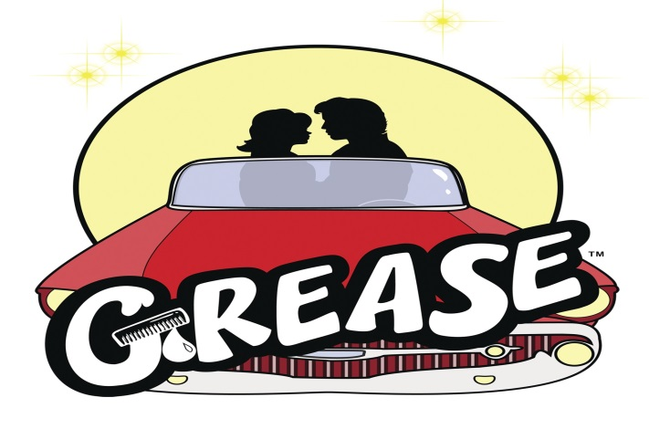

By arrangement with

THE COLLEGE THEATRE

22, 23, 24 NOVEMBER

We hope you enjoy the show

