Newbridge College Self Evaluation Report and Improvement Plan 2018-2019

In looking at teaching and learning in the school last year, we focused on three areas:
- Collaborative Learning
- Literacy
- Numeracy
We will continue our focus on these three areas in 2018-2019, and also begin to look at how we can further help out students through Wellbeing, and we will be communicating with you about this as the year develops.
In this report we would like to communicate the things that we are doing well in these areas, and the things we have tried to improve, and the aspects of teaching and learning that we will prioritise this year.

Collaborative Learning
Students working together in pairs or small groups are an intrinsic part of the New Junior Cycle curriculum, and an important way to learn across all years in secondary school.
In the College we already:
- Use a wide range of collaborative learning strategies: Our subject inspection reports from recent years in Science, French, Business, Irish and English all commended our use of collaborative learning.
- Teach collaborative skills to students
- Have an excellent understanding among students and staff of how collaborative learning is good for building relationships, improving memory and retention, and making things clearer and easier to understand.

Last year we surveyed students and found that:
- All either agreed or partly agreed that group work is good for relationships
- 84% agreed or partly agreed that group work is good for memory
- 90% agreed or partly agreed that group work is good for understanding
We also surveyed teachers and found that on average they used collaborative strategies 5-6 times per week. They also told us that collaborative learning is good for:
peer learning, building confidence, problem solving, sharing ideas, developing relationships, communication skills, self-esteem, higher level thinking, different learning styles, oral language skills, leadership, student centred practice, ownership of learning, inclusivity, differentiation, and students being reflective.
Priorities for Improvement:
Although collaborative learning is used well in some subject areas, we would like to develop strategies that involve collaboration across all subjects, and increase the number of times your child will get the opportunity to collaborate with others.
We are working with subject departments to:
- Create easy and quick ways to collaborate in classes
- To share ideas among teachers that will lead to creative and interesting ways for students to learn together
- Ensure that when we do group work it is effective for learning and that all members of the group are accountable

You can help by:
- Asking your children about the types of paired and group work they are doing.
- Explain to your children the importance of working with others and their own responsibilities about collaborating, contributing and listening to others.

Numeracy

As a school we have excellent Maths results, and this year the numbers of students achieving H1 and H2 grades for the Leaving Certificate was 18 (32.7% of those that sat Higher Level), almost 14% above the national average. We have also worked in the past to emphasise ‘numeracy moments’ in other subjects.

Priorities for Improvement:
This year we are beginning a new cycle of developing and teaching numeracy skills, not just in Maths, but across all subject areas so that all students get a clearer idea of how numeracy is important in all areas of life.

We are working with all teachers to:
- Raise the awareness and teaching of numeracy skills in all subjects
- Making numeracy visible around the school
- Developing the use of graphic organisers as a learning tool in a range of subjects

You can help by:
- Bringing your children’s attention to numeracy skills in all aspects of everyday life.
- Talk to your children about how they use numeracy in different subjects.

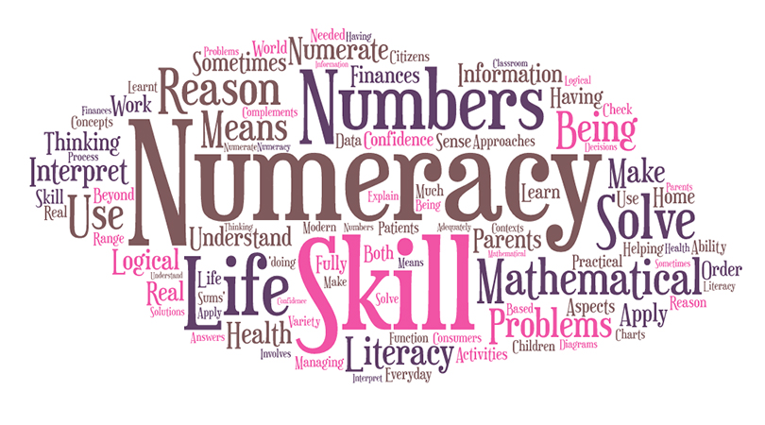

Literacy:

In Newbridge College we provide excellent support for student’s literacy skills through the English Department, and with the specific teaching of literacy skills in all subjects. We carry out extensive testing of student’s literacy skills throughout the school to ensure they get appropriate supports for their literacy needs.

Priorities for improvement:
The literacy team in the school have decided to focus on reading for pleasure and creating a positive reading culture in the school.

Here is what we plan to do:
- The library will be at the centre of this initiative, and we are hoping to achieve the National Wellread Award by the end of the year. This will involve students, parents, teachers and other College staff.
- We will be developing further the paired reading programme involving Transition Year Students and First Years which was initiated last year.
- We will be encouraging all teachers and staff to share their favourite books and make recommendations to students.
- We will have a series of events with visiting authors to give students a sense of the pleasure and relevance of reading and writing.

How can you help?
- We will be contact throughout the year about ways you can help with our Wellread initiative, we look forward to your involvement.
- Ask you children about the College library and encourage them to visit; and pay us a visit yourselves – we are open between 4pm and 5pm every day except Wednesday.
- Share your own love of reading with your children, and visit your own local library with them.

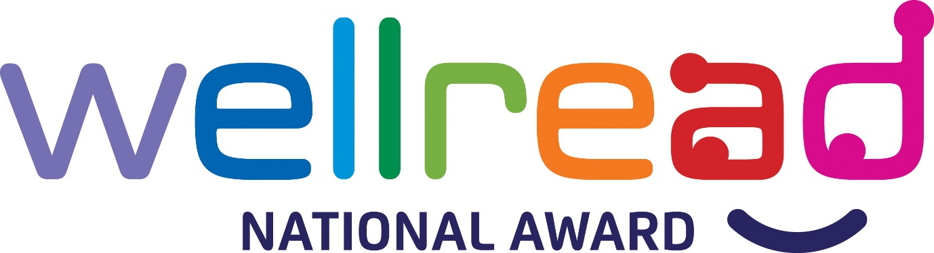

Here is some information about how we are carrying out our work and about what the Department of Education and Skills requires us to do.
School time and holidays
The Department requires all post-primary schools to have 167 school days each year, and a 28-hour school week.
This year we will have 167 school days, from 27.8.2018 to 31.5.19. Our school week is 28 hours.
The Department sets out a standardised school year and school holidays.
This year we will take all our school holidays within the permitted time. YES / NO
The Department sets out arrangements for parent/teacher meetings and staff meetings. This year we will have 6 parent/teacher meetings and 3 staff meetings, all in line with the Department’s regulations.

Looking after the children in our school
The Department requires schools to follow the Child Protection Procedures it has set down. Our board of management has agreed in writing to do this. YES / NO
All teachers know about the Procedures and we have told
all parents about them and how we follow them. YES / NO
Our Designated Liaison Person (DLP) is Mr Pat O’Brien
and our Deputy DLP is Ms Alison Bradshaw
Enrolment and attendance
The Department requires schools to have and publish an admissions policy, to record and report attendance accurately, and to encourage high attendance and participation.
We have an admissions policy and it is published. YES / NO
We reviewed and updated our admissions policy in January 2018
We keep accurate attendance records and report them as required. YES / NO
We encourage high attendance in the following ways:
- By emphasising the importance of class contact time to students through the teachers, Deans and school management.
- By sending home texts if a student is absent, logging the reason for the absence, and following up if we do not have authorisation from parent(s)/guardian(s).
- By meeting with students if issues with attendance and supporting them to improve their attendance.

This is how you can help:
- Encouraging your child to attend school unless they are genuinely too unwell to do so.
- Try to schedule appointments outside of school hours, and holidays outside of the school term, if at all possible.
- Let us know if you are having difficulty getting your child to school for any reason, and see how we can help

Positive behaviour for a happy school
The Department requires schools to have a code of behaviour, and asks us to consult parents and students about it. We do this. YES / NO
Our code of behaviour describes and supports positive behaviour. YES / NO
We have a very clear and high-profile anti-bullying policy in our school. YES / NO

