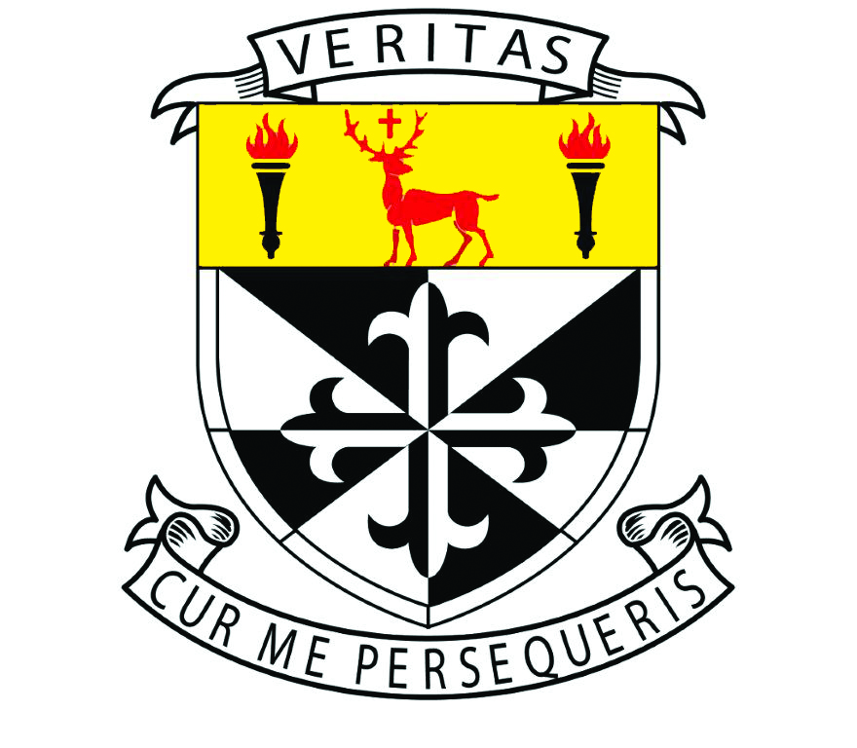

Newbridge College

ANNUAL ADMISSION NOTICE

in respect of admissions to the 2021/2022 school year

Admission Policy and Application Form
A copy of the school’s Admission Policy and the Application Form for Admission for the 2021/2022 school year is available:
to download via the following link: www.newbridge-college.ie
on request by emailing: info@newbridge-college.ie
on request by writing to: Newbridge College, Newbridge, Co. Kildare W12 C241.

PART 1 - Admission to the 2021/2022 school year

Application and Decision Dates for admission to 2021/2022
The following are the dates applicable for admission to First Year

The school will commence accepting applications for admission on | 01/10/2020
The school shall cease accepting applications for admission on | 22/10/2020
The date by which applicants will be notified of the decision on their application is | 12/11/2020
The period within which applicants must confirm acceptance of an offer of admission is | 27/11/2020

Note: the school will consider and issue decisions on late applications in accordance with the school’s admission policy.

Number of places being made available in 2021/2022

The number of places being made available in first year is | 150

PART 2 - Admissions to the 2020/2021 school year
Information regarding the admission process
for the Intake Group for 1st year for the 2020/2021 school year

In respect of the 2020/2021 school year, the total number of applications for admission received by the school was 498.

Breakdown of places allocated for the 2020/2021 school year:
Number of places available: |  | 146
Number of applications received: |  | 498
Number of offers made and accepted under each of the criteria: | Scholarships | 2
 | Siblings | 80
 | Staff | 1
 | Dominican Nephews / Nieces | 0
 | Past Pupils | 15
 | Other | 48
Total number of offers made: |  | 146
Number of names placed on waiting list for the school year concerned: |  | 156

