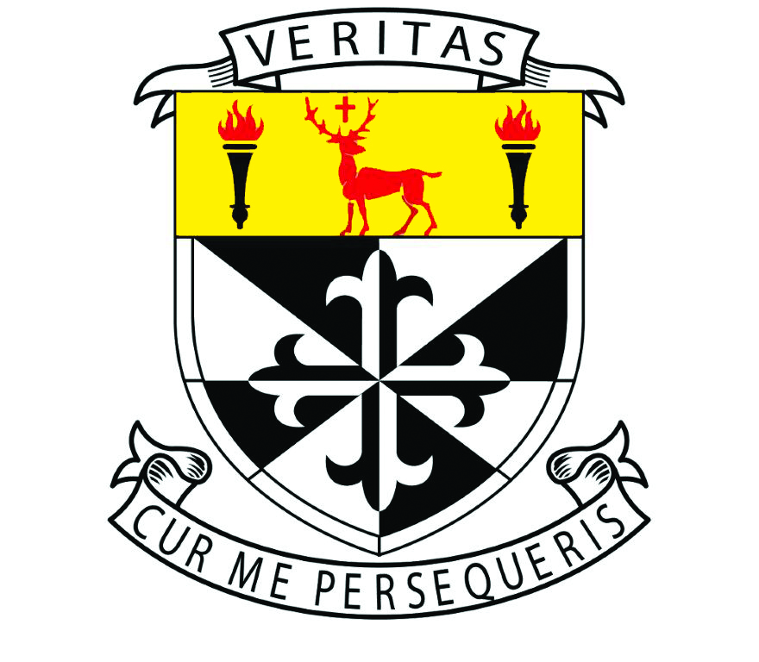

Newbridge College

ANNUAL ADMISSION NOTICE

in respect of admissions to the 2022/2023 school year

Admission Policy and Application Form
A copy of the school’s Admission Policy and the Application Form for Admission for the 2022/2023 school year is available:
to download via the following link: www.newbridge-college.ie
on request by emailing: info@newbridge-college.ie
on request by writing to: Newbridge College, Newbridge, Co. Kildare W12 C241.

PART 1 - Admission to the 2022/2023 school year

Application and Decision Dates for admission to 2022/2023
The following are the dates applicable for admission to First Year

The school will commence accepting applications for admission on | 08/10/2021
The school shall cease accepting applications for admission on | 29/10/2021
The date by which applicants will be notified of the decision on their application is | 12/11/2021
The period within which applicants must confirm acceptance of an offer of admission is | 26/11/2021

Note: the school will consider and issue decisions on late applications in accordance with the school’s admission policy.

Number of places being made available in 2022/2023

The number of places being made available in first year is | 146

PART 2 - Admissions to the 2021/2022 school year
Information regarding the admission process
for the Intake Group for 1st year for the 2021/2022 school year

In respect of the 2021/2022 school year, the total number of applications for admission received by the school was 499.

Breakdown of places allocated for the 2021/2022 school year:
Number of places available: |  | 146
Number of applications received: |  | 499
Number of offers made and accepted under each of the criteria:

 | Siblings | 92
 | Staff | 3
 | Dominican Nephews / Nieces | 0
 | Past Pupils | 20
 | Other | 31
Total number of offers made: |  | 146
Number of names placed on waiting list for the school year concerned: |  | 239

