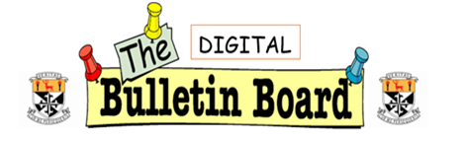

**January 2022**

***To open the year our focus for the Teaching & Learning Bulletin is Wellbeing and Anti-Bullying. During our Department Inspection 24 November we had the opportunity to share some of the wide ranging supports we have in place to promote wellbeing and anti-bullying in our school. Here are just a few, and please share any others you would like included in the next edition:***

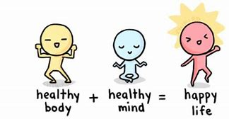

**Health & Body Image Workshops**

**The sixth-year girls are currently completing a series of health and body image workshops with Ms. Mulvey. The objective of these workshops is to provide evidence-based education on health and well-being, social media use and its impacts, and to provide students with a toolbox of strategies they can implement to help develop positive body image.**

**All 6th year girls will have the opportunity to complete these in a block rotation throughout the remainder of the year.**

**The Shona Project facilitated workshops with 2nd Year girls last week and are scheduled to work with our 1st year girls next month. Their aim is to meet and talk to girls throughout Ireland about how to find their place and identity. They encourage girls to be kind to each other, and especially to themselves. In their own words ‘Here at Shona, we celebrate women from all over the world, those who succeed and those who overcome, those who lead and those who think, those who win and those who learn. We share our stories so that we don’t feel alone. We laugh, learn, try and cry together.’ Thanks to the 1st and 2nd Years Deans, Maria Archbold and John Joyce for organising.**

**For more information visit:** [About - The Shona Project](https://shona.ie/about/)

**The Transition Years were all involved in Sona Resilience Workshops which focused on hope and resilience in a real and authentic way. They explored positive psychology, the power of the subconscious mind and dealing with the natural high and lows of life.**

*********ABCs Antibullying and Cyber Safety Committee is led by Katie Scully and involves*** 4th and 5th years who work on cyber safety awareness and safer internet day. 2 students are trained with Webwise and they in turn train 10 or 12 others. This creates a large group who work on activities, debates and quizzes used with 1st and 2nd years during Safer Internet Day in February. Students follow up with cyber safety talks in SPHE classes.

The Learners’ Voice Team, facilitated by Deirdre O’Callaghan, are focusing on **Student Target Setting Cards** this year, to help students develop to their full potential academically, personally, socially, etc. whilst in Newbridge College. Eight teachers are currently piloting this with their classes. The Target Setting process is a great tool for opening specific dialogue between a teacher and student regarding a student's learning.  Students have noted improved motivation, more effective study, and increased ownership of their own learning as a result of their involvement in this process.

**Newbridge College Learners’ Voice Team Represented at OECD**

Congratulations to Julia Moore and Finnian King who have been selected to work with the OECD (Organisation for Economic Co-operation and Development) on their Student Voice Team, for the *2030 OECD Future of Education and Skills - Student Voices on Curriculum Design* campaign. Our students will represent Newbridge College on a global platform with the OECD and will help shape the future of education and improve the learning experiences of students around the world. We are very proud of Julia and Finnian and what they have achieved. We wish them the very best in their future work.

**We have introduced two new Junior Cycle Wellbeing modules this year:**

**‘Relationships First’ facilitated by Katie Scully creates opportunities for students to develop their listening skills, practice empathy and explore the importance of communication and relationships in their lives**

**The Inclusion Module created by Aisling Moran aims to develop understanding and connection with others, with a particular focus on issues relating to the LGBTI community, additional educational needs, gender and race & heritage**

**Emotional and Physical Wellbeing: Managing Stress Effectively**

A Stress Management Workshop took place for 6th Year students in Newbridge College. This was facilitated by Mary Briody. Mary works in a private practice as a child and adolescent psychotherapist. Through the workshop students were enabled to move towards a greater sense of wellbeing with a road map to navigate the Leaving Cert year.

A follow-up 'Emotional and Physical Wellbeing' session took place for staff, thus enabling a whole school approach to promoting wellbeing.

