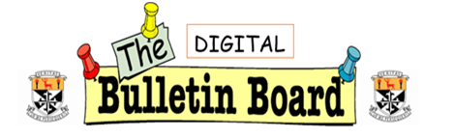

**September/October 2021**

Subject Leaders

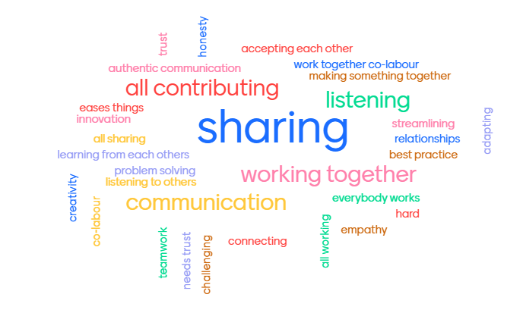

Our new Subject Leaders for 2021-2022 came together last term for a session sharing their ideas on collaboration, their hopes for the role, and what would be useful in terms of meeting time next year. Above is a graphic of the group’s ideas about what collaboration really means. They have led their departments in teaching and learning planning sessions following their own communities of practice this year, and we look forward to a year of collaboration and progress. Some Subject Leaders are also taking part in a Community of Practice with local schools - the PBS, Newbridge, Piper’s Hill College and CBS, Naas.

**The Learner Code**

**A small group of teachers led by James Cash are in the process of developing a Learner Code to pilot with 2nd years to develops skills and behaviours for learning. We have surveyed 2nd year classes about their learning skills and values and a review of this data is ongoing by the Learner Code focus group.**

**The Calm Room**

Martins 2 has been redecorated and furnished with more inviting lighting and furniture to provide a calm space for students who may need to make use of it during the day. We are thankful to the Parents’ Association who provided a bursary to allow this to happen.

Additional Educational Needs Team Support for Students' Reading

The AEN team are piloting a reading programme they have designed for our school with some students with a diagnosis of dyslexia.  It takes about 12 weeks to complete.  Parents and teachers of students participating in the programme receive an email with more information about this support.  Students are tested at the beginning and the end of the programme to determine its effectiveness and to inform the way the programme develops.  The AENT thank you for your support for students' literacy by highlighting and teaching keywords and their meanings in your subject.

**Learners' Voice** 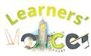

The Learners' Voice team continue their work again this year in Newbridge College.

The overall focus of our work in Learners' Voice is to continue to improve the teaching and learning in Newbridge College and to have students voice heard and acted on in matters that affect them. This dialogue empowers the students enabling them to truly have a voice informing the direction of the development of their educational environment.  There are many benefits for students becoming involved in this area. Student's active participation facilitates enhanced student-teacher relationships and increases students' ownership of their own learning.

From the Geography Department: 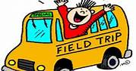

Our TYs have completed their annual hike. Next month some Junior classes and Senior will take part in the **Globe air quality campaign**. The Air Quality measurement period is from October 11th to November 8th. External air quality will be measured in three areas of the school.

Our 6th years classes are preparing for their pre-mock exams. Their geography field trip in November takes place in Kippure Wicklow.

1Y Penpals

Helena Kilbane’s 1Y English students have been matched up as penpals with 1st years from St. Flannan’s in Ennis (Kayleigh Maher – past teacher of NC) and they’re writing letters to each other. They have been very excited about it!

Here is a photo of them below receiving their letters from St. Flannan’s today.

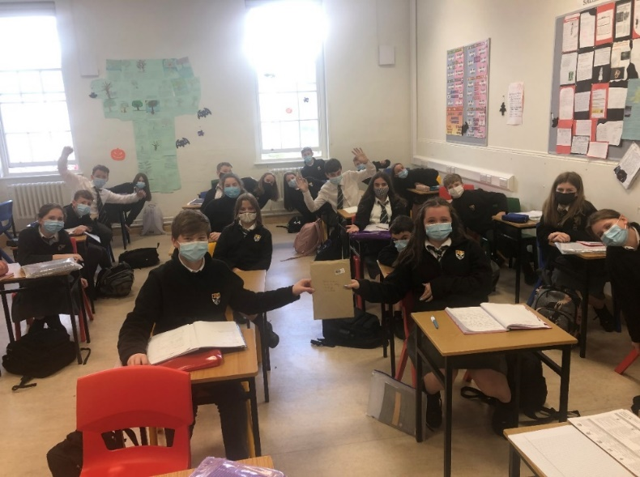



**An exciting time for the library as we continue to develop the space and order in our new stock for the year. We are delighted to introduce our Newbridge College Library Prefects for the academic year 21/22, who will help organise and promote reading for pleasure throughout our school. Jordan Whitfield (Senior Prefect/trainer 6th year), Lucy Harkin (3rd year), Joanna Lipska (3rd year), Daire Carey, (3rd year), Martha Kennedy (TY), Eva Lyons Doyle (TY), Oscair Murphy (TY), Reuben Thomas (2nd year), Isabel Connolly (1st year), Emma Coyle, (1st year), Niamh Ahmed (1st year), Katie Kelly (1st year).**

***Class set of Chromebooks***

Newbridge College Library received a brand-new set of Chromebooks – a lot of teachers are bringing their class groups down to use the library space to carryout research for various different projects and classroom-based assessments.

***Newbridge College Celebrates National Comic Book Day***

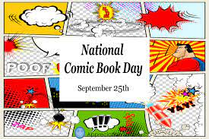The library celebrated National Comic Day, Saturday 25th September and teamed up with Big Bang Comics, Dundrum. We have a large range of comics and graphic novels available and encourage teachers to use the library space and have a comic reading class.

This has already proved very popular with all year groups, especially art students –special thanks to the Art Department for their support, looking really forward to seeing some comic inspired artwork to brighten up our school walls!

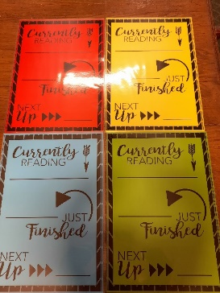 *‘***What I’m currently Reading’ Poster Initiative– Promoting reading for pleasure across all departments.**

We have been busy laminating our updated *‘What I’m currently reading posters’*, which have been distributed to teachers. We aim to promote a love of reading across all departments by sharing our recommendations with our students. We would love to see them on every classroom door across the school.

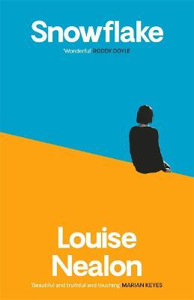**Newbridge College Book Club**

Now that restrictions are lifting, our Parent and Staff book club can recommence and we will begin by reading **Louise Nealon’s ‘Snowflake’.** Our first meeting this year will be on Monday, 18th October 2021 at 7pm in Newbridge College Library, all are welcome.