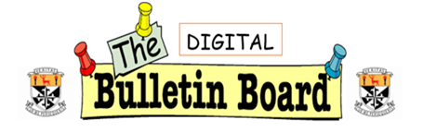

**March 2023**

**IMTA Junior Cert Maths Competition**

This is an annual national Maths competition run by the Irish Maths Teachers Association for 1st year students. This year 21 Newbridge College 1st year students sat the online Maths exam after school on Wednesday the 22nd of February.

There were over 15,000 entries from 216 schools across the country. 356 were completed through Irish. 2 students achieved maximum points and a total of only 62 achieved over 80%. The mean was 32.0% and the standard deviation was 14.7%.

The students under the guidance of Mr. Falvey gave up their Thursday lunchtimes in January and February to prepare for this challenging exam. Their hard work certainly paid off as all our students scored higher than the national average and two students, Juliette Hurley O’Dwyer and Jules Barry scored 87 and 85 respectively and will be awarded and IMTA Maths trophies for their outstanding results. Well done to everyone that took part in the competition.

**6th year retreat - Glendalough**

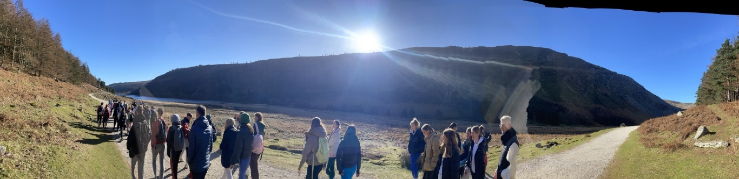

**The 6th Years enjoyed a fabulous day in Glendalough for their retreat in February accompanied by Yvonne Carey and Fr Anthony.**

**Restorative Practices Community of Practice**

**We hosted our first local Community of Practice for teachers, social workers and parents trained in Restorative Practices in our local area. It was a rare opportunity to connect, share practice and build community.**

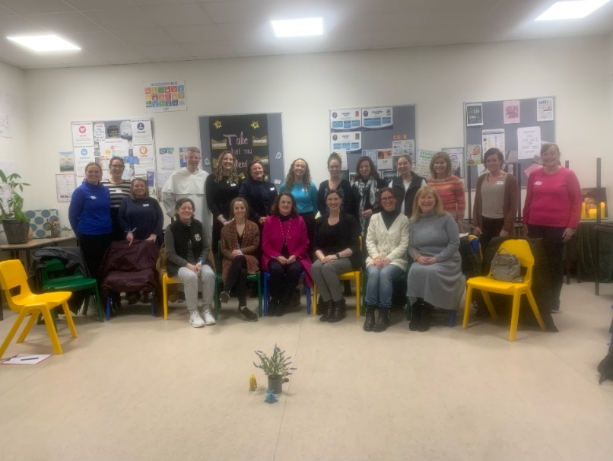

**Restorative Practices Student Team**

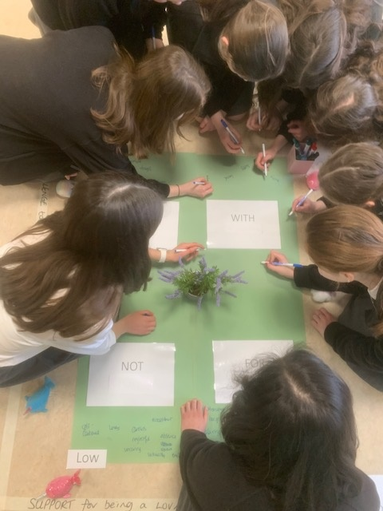**Our 2nd Years signed up for some RP Training after school – here they are exploring the ‘Relationship Window’. Their next steps are to help set and a 1st Year ‘Restorative Café’ and support them developing skills in empathy, listening and building positive relationships.**

**Instructional Leadership**

**Our second cohort of the Instructional Leadership Team (Julie O’Keeffe, Rachael Hearne & Yvonne Carey) attended their 3rd training session this month. Below is 2E engaged in a collaborative learning strategy in action. You can find out more the innovative approaches to teaching and learning that is heart of IL at**[**www.instructionalleaderhsip.ie**](http://www.instructionalleaderhsip.ie)

**Student Council**

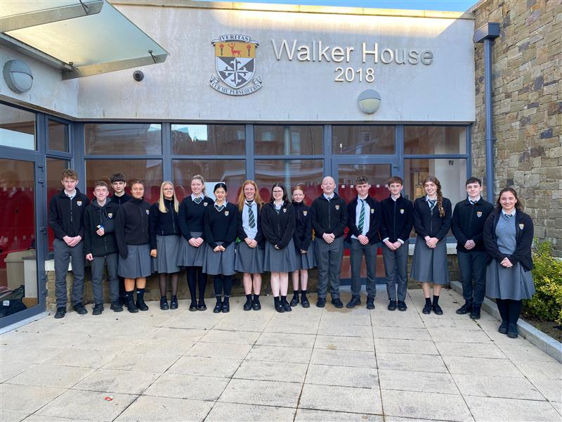

**The Student Council representatives met with the Parents’ Association to explore possibilities for funding for student centred projects. One area of focus will be the Green School’s Committee and recycling.**

**Young Environmentalist Award 2023:**

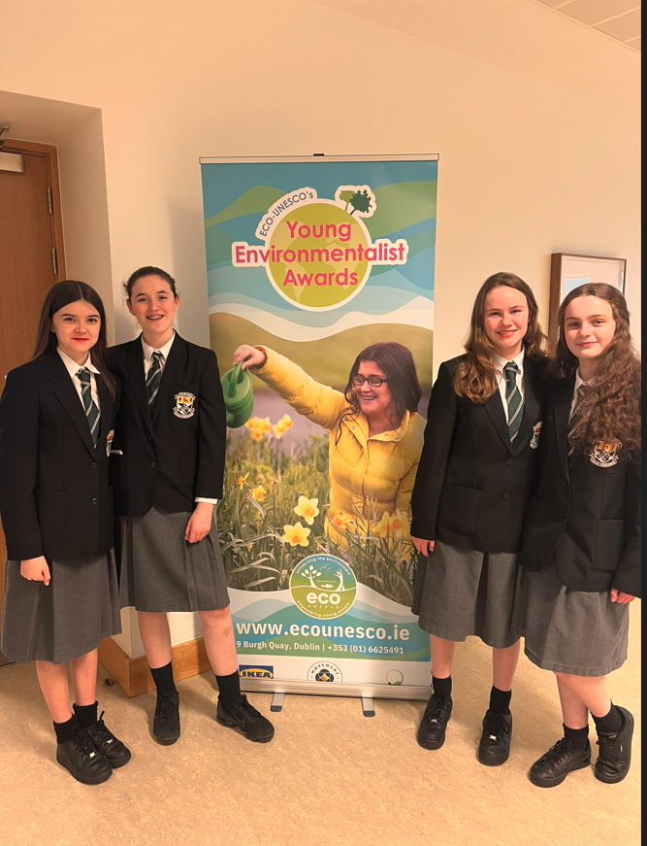**Four 2nd year CSPE students are working on a project for the Young Environmentalist Awards 2023. Their project was selected for the regional semi-finals. As part of their project they are introducing compost bins into our school. Congratulations to Isabel Connolly, Freya Nolan, Clodagh Lannon & Aoife Mackay.**

**BT Young Scientist Competition**

Emily Johnson (1st Year) Tara Mulhall (5th Year)

This year saw the return of the competition to the RDS, and Newbridge College had 4 entries that made it through the tough selection process to exhibit in January. Their mentors are Dermot Walsh and Anne Marie Davis

Emily Johnson 1st Year looked at “**Optimizing wind turbine efficiency”**. During this project Emily sought out to investigate varying blade orientations, for optimal performance using a consistent flow rate of air on a wind turbine.

She made 6 different sets of blades and tested the power outage from each set. She found that the thin blades with tips bent upwards worked best.

Emily won 1st prize in her category Physical, Chemical and Mathematical Sciences in the Junior Section.

Tara Mulhall, 5th year, also brought home 1st prize for her project in the Senior Category.

“Adapting AI code to determine voting preferences from a voters digital footprint”

Her project also looked at using Neural Networks to create Art.

Tara was also the winner of the Fr. Tom Burke Bursary, for Communication.

Congratulations also to Rían Hearne, 2nd Year, for work on his project “What *is the best way to communicate complex topics with a non-expert?*An investigation into teaching methodologies”, and TY students, James Brophy, Ruby Hennessy and Louis Hayden who displayed their project “To investigate the brachistochrone curve”  - the fastest 2-D path from point A to B under the influence of gravity.

*Louis Hayden, Rían Hearne, Tara Mulhall, Ruby Hennessy, Emily Johnson, James Brophy*

**Rewards System**

Our new Rewards System has been launched in our school earlier this year. We want to build on our culture of acknowledging achievements and celebrating successes of our students within our school. The intention is to promote positive behaviours in an academic and holistic sense across all year groups. A variety of rewards are allocated to the top student point scorers and classes in each year group each term in our Achievement Assemblies.

Thanks to the Learners’ Voice team, and supporting teachers who initiated, developed, and helped ensure this became a reality.

**Alert Training**

The international evidence-based [ALERT](http://www.alertprogram.com/) programme *‘How Does Your Engine Run*’ aims to help students monitor, maintain and change their level of alertness so that it is appropriate to the situation or task. The programme identifies students’ sensory needs and preferences and encourages student use of sensory motor strategies to support self-regulation so that their engines are running ‘just right’. Some of the approaches and ideas were shared during the AEN session at our recent Féilte.

[The ALERT Programme | NBSS](https://www.nbss.ie/interventions-and-projects/behaviour-for-learning/the-alert-programme)

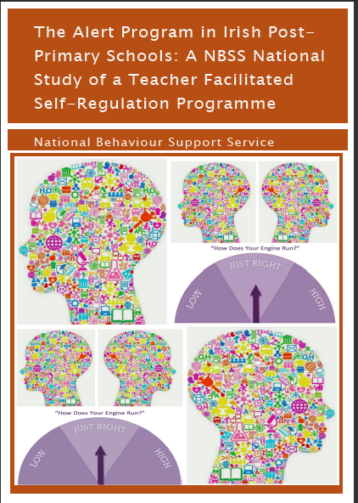

***Féilte Scoile***

*Our Féilte Scoile in Newbridge College took place on March 13th, 2022. This is a celebration of teaching and learning led by teachers in our school and is a great opportunity for teachers to share their learning, resources, and innovative ideas with each other.*

*We would like to sincerely thank all the facilitators of our Féilte sessions, who gave so generously of their time, effort, and expertise.*

**Junior Workshops:**

*In recent weeks we organised* ***'Man up to Misogyny'*** *workshops, facilitated by Inspireland for boys in 1st and 3rd Year, 2nd Years are having their workshop in April.*

*At their core, these are creative writing workshops that raise awareness around the language and culture of hetero-male supremacy. The workshop was adapted to suit each different age group.*

*Within the workshop students looked at the beliefs bestowed upon young men by the influencers and media that they engage with, and they were challenged to redefine the values by which they measure their individual masculinity/humanity. The workshop is a series of short, quick fire writing exercises and group discussions interspersed with videos of rap and spoken word poetry. The students engaged extremely well with the workshop and really enjoyed it.*

Our Junior girls our experiencing workshops with The Shona Project focused on Building a Positive Mindset, Using Our Voice & Building Self-confidence and Our Anxiety Toolkit In their own message to parents the facilitators said: ‘*Today we carried out a workshop with the young women in Newbridge College, and we hope that through our unique, honest and open approach, we have lit a spark of change.  We know through listening to these incredible girls, that they need support to face the challenges that today’s society places on them, and working with you, together we can help deliver that support.’* Find out more at [www.shona.ie](http://www.shona.ie)



On Thursday, March 2nd, Newbridge College celebrated World Book Day 2023.

Promoting literacy and encouraging students to read for pleasure has always been a priority in our school.

Newbridge College received the **PDST WELLREAD Award in 2019** and we enjoy taking these opportunities to encourage students to read for pleasure.

To celebrate the day and promote reading throughout our school, we launched a number of competitions, including the ‘Decorate your Classroom Door’ competition, ‘‘Design your own Book Cover’ competition and ran a special World Book Day Treasure Hunt. Teachers also took their classes to the library that day to encourage them to pick a book that they might enjoy reading.

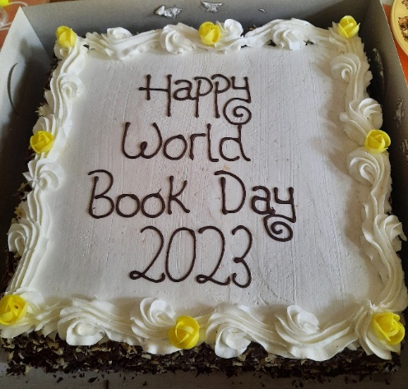

Staff enjoyed some lovely World Book Day cake on their coffee break too, in exchange for writing down their book recommendations, so we could promote reading within our staff room.

The Library Prefects judged all competitions and as the standard was quite high, they had a difficult job deciding on the best entries however, they settled on the following...

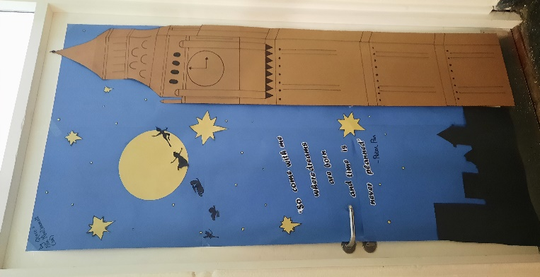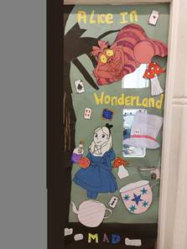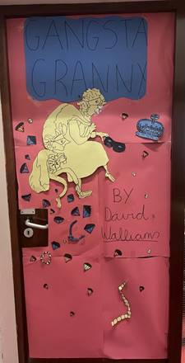

1st place Ms. Hearne - inspired by the book 'Peter Pan' by J.M Barrie.

2nd place Ms. Murphy - inspired by the book 'Alice in Wonderland' by Lewis Carroll.

3rd place Ms. Carey - inspired by 'Gangsta Granny' by David Walliams.

Congratulations to the winners of the ‘Design your own Book Cover’ competition.

1st place Siun Casey (1W)

2nd place Brandon Ryan (1W)

3rd place Grace Mc Conaghy (1V)

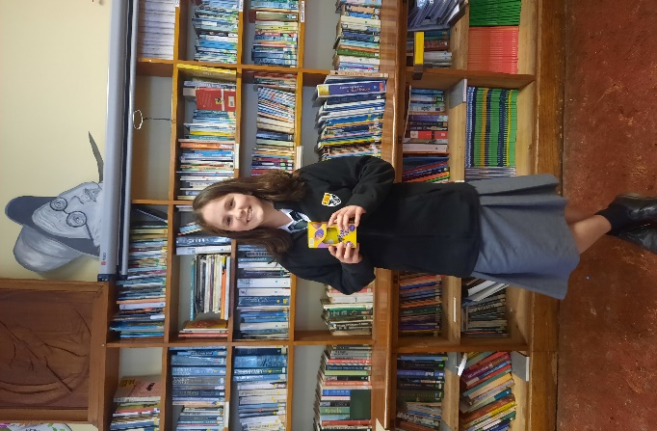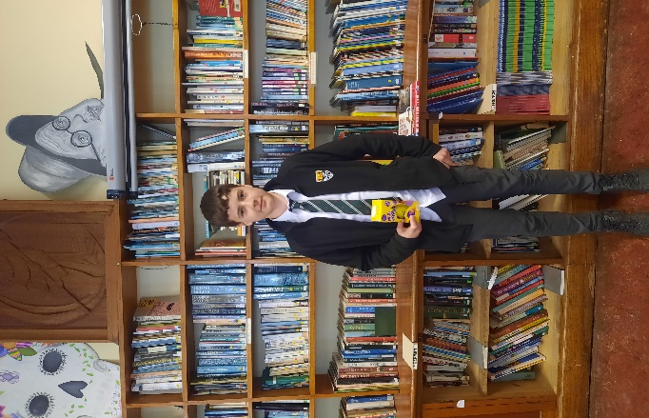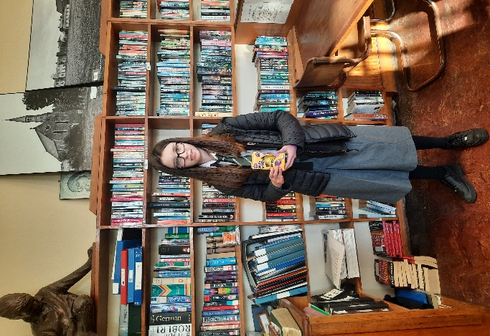

Not forgetting our ‘World Book Day Treasure Hunt’ winning team…

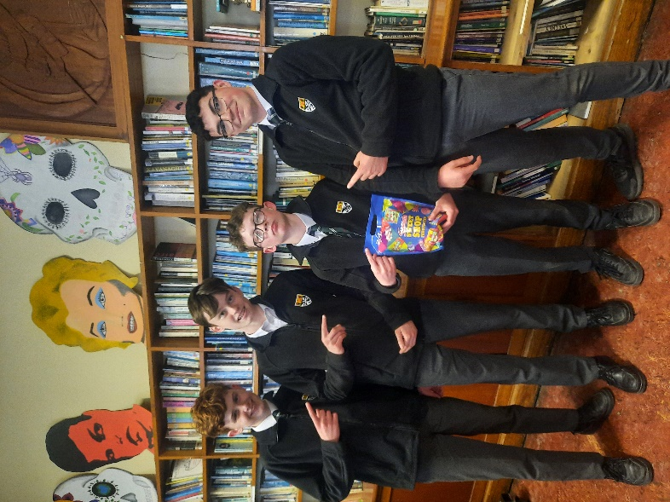(L-R) Martin Phelan, Sean Kelly, Ollie Mc Cartan and Ross Whitehead

Our school community really enjoyed taking part in the activities and the footfall in the library has dramatically increased in recent weeks.

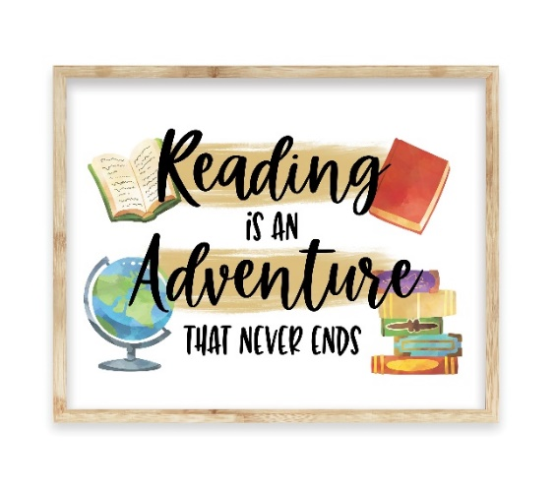

**Library Recommendations**

**Most popular books in our school library right now…**

1. Heartstopper Vol. 1 by Alice Oseman
2. Alex Rider (Stormbreaker) by Anthony Horowitz
3. ‘A Good Girl’s Guide to Murder’ by Holly Jackson
4. ‘Harry Potter and the Cursed Child’ by JK Rowling
5. ‘To All the Boys I’ve Loved Before’ by Jenny Han

**Staff Recommendations**

**Most popular books read by our staff right now…**

1. **‘**Black Box Thinking’ by Matthew Syed
2. ‘Eleanor Oliphant is Completely Fine’ by Gail Honeyman
3. ‘Where the Crawdads’ Sing by Delia Owens
4. ‘Act of Oblivion’ by Robert Harris
5. ’56 Days’ by Catherine Ryan Howard

And to finish….

**Rachel Thornton**, Class of 2019, had the opportunity to direct and stage a play in the prestigious UCD DRAMSOC theatre last month. It garnered fantastic reviews and was hugely successful. Well done to Rachel.