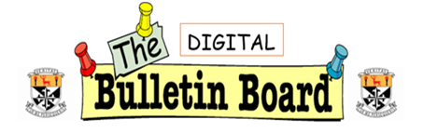

**October 2022**

The amazing cast and crew of ‘Shrek the Musical’ who performed 2 matinees and 3 evening performances to a full house for every show. Well done to all involved!

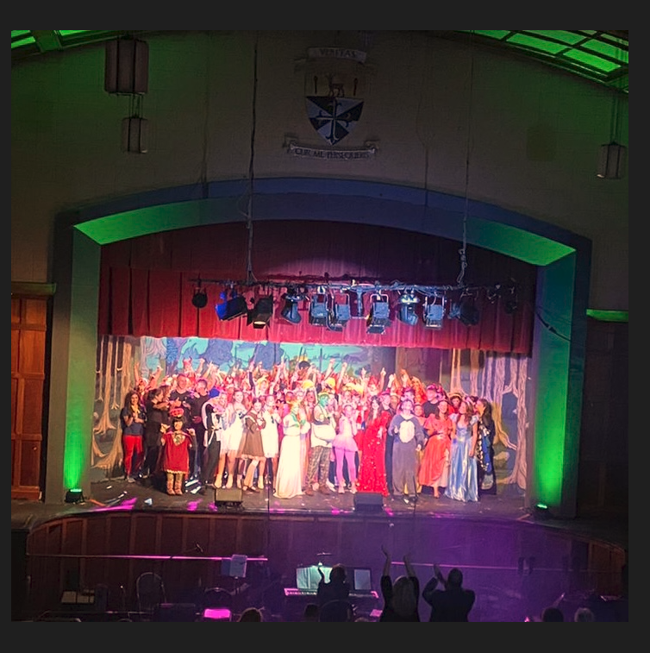

**Transition Year Activities:**

Transition Year students attended a workshop facilitated by the RCSI and the Rotunda in Dublin on Monday 3rd October. They. They also experienced a walking tour of Dublin, run by Secret Street Tours. Students have also just complete their overnight hike in the Wicklow mountains….

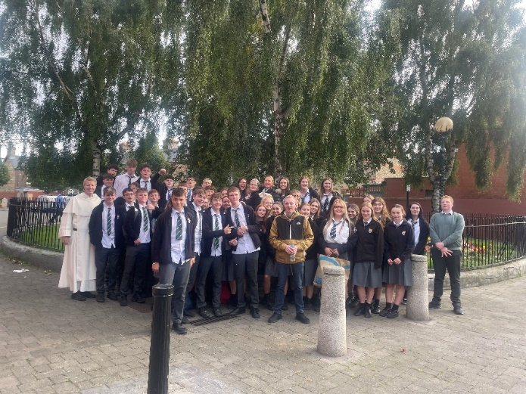

**The Learner Code**

Students and staff have collaborated to develop a Learner Code for Newbridge College. We hope that this Learner Code will support students and teachers reinforce expectations around learner-focused behaviour and promote self-awareness and reflection in students.

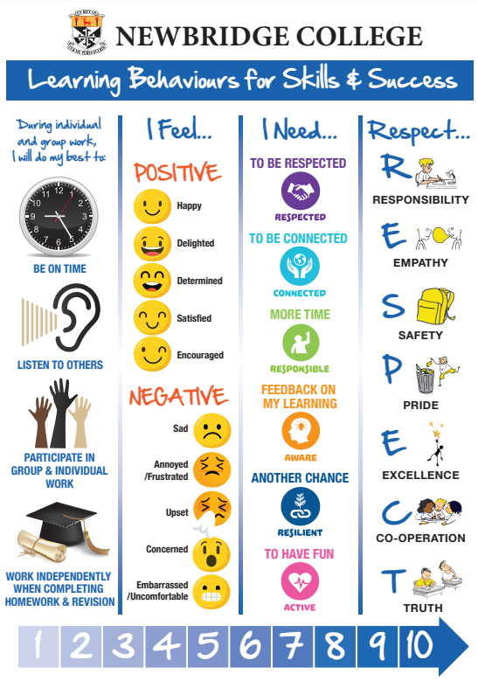

**Restorative Practices**

**The Restorative Café runs every Monday lunchtime with 2nd years girls and is a chance to connect and practice some RP skills. An Introduction to Restorative Practice training course I also underway with several teachers from our own school along with staff from The Holy Family, The Curragh Post Primary and social workers from the Family Resource Centre in Newbridge. The course is being facilitated by Katie Scully who completed her Training of Trainers course over the summer and other members of the RP Team.**

**Promoting Positive Behaviours/Rewards System**

The focus this year in Learners' Voice is ' Promoting Positive Behaviours - Rewards'. We are looking at how we can build on our culture of rewards and celebrating achievements within our school. Ultimately, we want to promote positive behaviours for learning across all year groups and promote wellbeing.

The Learners' Voice group have generated lots of great ideas since September. Teachers are also working in conjunction with students on our newly established Positive Behavioural Leadership Team. Many thanks to all involved!

**Subject Department Development Goals**

**Our Subject Departments across the curriculum have engaged with a process of agreeing a teaching and learning goal, exploring** **options, and agreeing action steps - all to improve students’ experiences and outcomes. There are a variety of goals across departments, including improving planning around learning outcomes, more effective assessment and feedback and student-centred skills and methodologies.**

***6th Year Study Skills Session***

*Our 6th Years were able to chat to some of our past pupils about managing themselves in 6th year, how best to approach study and homework and heard hints and tips from those who recently went through the Leaving Cert experience.*

*Attached is a picture of the past pupils who generously gave up their time, some even missing Fresher’s Week social events, to come back and chat to our next graduating class.*

*Finnian King Class of 2022*

*Ceola Donlon Class of 2021*

*Libby Carty Class of 2021*

*Sadhbh Murphy Class of 2022*

*Elliot Davis Class of 2017*

*Alex Byrne Class of 2021*

**NCCA Focus Group**

**The National Council for Curriculum and Assessment held a focus group with a group of our senior students inviting their response to the new Leaving Certificate Drama, Film & Theatre Studies curriculum.**

**An Triail Theatre Visit**

**Our 6th Year Irish students attended the Axis Theatre to see the play An Triail.  They had a great day out and enjoyed seeing some of their Irish literature come to life.**

**Target Setting**

We are continuing our work this year on Target Setting. Ten teachers and their respective students are partaking in a pilot project until Christmas. The aim of Student Target Setting Cards is to help students develop to their full potential academically, personally, socially, etc. This helps students to assess their performance so a plan for improvement can be made. Our focus will be on positive outcomes and successes with each review. Students can use this learning and apply it in future target setting.

The target cards are student friendly, clear, and concise. Accessible language is used and reflection on students’ learning is an essential component of this approach.

Recycling News

The Green Schools have made great progress over the past 6 months with Recycling.

Last year we ran a used battery collection competition, with over three thousand used batteries collected and recycled at the Kilcullen recycling plant. Well done to the 1st years for collecting the most batteries.

Roughly 25 blue recycling bins were purchased for the corridors and the classrooms, and another 12 old bins were upcycled by painting them blue. Well done to the 1st and 2nd-year students who gave up their free time to paint these.

Last year a group of 5th-year students won 1st prize in a Neat Street's nationwide Tik-Tok competition. It was judged to be the best Tik-Tok recycling video in the competition. Well done to all involved and to Lauren McLoughlin for editing the video.

A small, laminated poster was also designed for each room to remind students and staff to turn off the lights when leaving a room (still a few more to deliver).

We also had a cycle-to-school day last year in May and another one this year on Wednesday the 21st of September. We would encourage both students and staff to continue cycling (or walking) to school whenever possible.

This week we unveiled the recycled bottle top mural, which is on display in the social area. A huge thank you to all the students and staff that collected over 2500 coloured bottle tops over the past six months. A special thank you to Etienne Thompson and Emily Kehoe (TY students at the time) who gave up many hours of their free time after school to put it together.

This year the current 2nd year CSPE classes are doing Bin Patrol once a week on all the bins in each classroom in the school to see if they are being used correctly. All students have been encouraged at assembly talks to use the recycling and general waste bins in the corridors, social areas, and in the Ref properly. Keep up the good work. It is making a difference.

There is also an enthusiastic group (both last year and this year) of 2nd year litter pickers. They collect litter in different areas around the school on Thursday afternoons. Their reward is a free meal in the Ref on Fridays. So, if anyone else would like to join in, please feel free to put your name forward.

Remember to dispose of your rubbish in the correct bins in the corridors and in the classrooms.

Blue Bins: Recycling products:    Paper, Cans, Bottles, Tinfoil, Popcorn packets, Crisp wrappers, Sweet wrappers.

Cream Bins:    General Waste: Food waste, Apple cores, Banana and Orange peels, and Curry chip cartons.

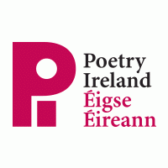**Poet Visit: Maeve O’ Sullivan**

On Tuesday 4th October, poet, writer and teacher, Maeve O’ Sullivan visited Newbridge College and taught workshops on how to write Haiku poetry.

These workshops were organised through Poetry Ireland and offered students a chance to understand how to write their own unique Haiku poem.



As part of her visit, Maeve also took the students out on a nature walk to inspire them and by the end of the sessions, our students had written a collection of very impressive poems.

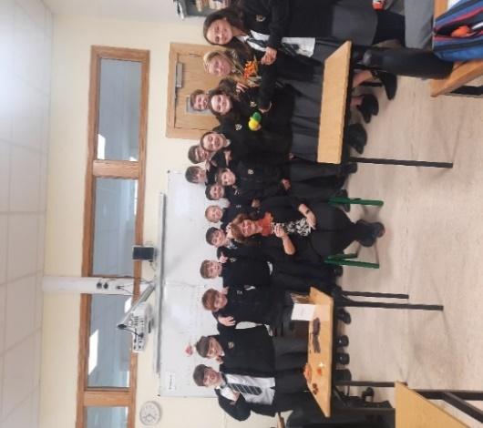 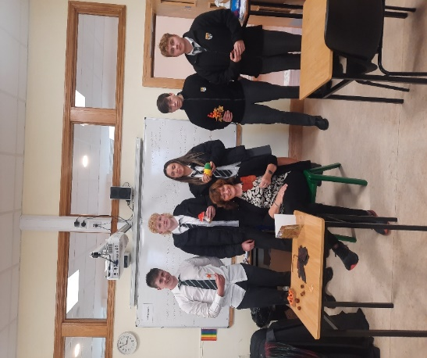

Maeve O’ Sullivan with students from 1W

Maeve O’ Sullivan with students from TYA



We recently advertised and interviewed students who applied to become Library Prefects.

We are delighted to introduce our Newbridge College Library Prefects for the academic year 22/23, who will help organise the library and promote reading for pleasure throughout our school.

1st year: Zuzanna Fitzpatrick, Aobha O’ Flaherty, Danny Mc Connell, Millie Matthews, Catherine Logan and Martin Phelan.

2nd year: Isabel Connolly, Ali Crosbie and Zoe Thomas

3rd year: Sarah Gorrell, Emily Conroy and Ivy Li.

TY: Kai Ziarek, Tia Earl, Daire Carey, Lucy Harkin and Joanna Lipska.

5th year Jenny Farrelly.

6TH year Cian Cosgrave.



Our school library has just received a delivery of brand new books. All the latest titles available now to borrow.

Some of the most popular titles that our Library Prefects recommend are ‘The Heartstopper’ book series by Alice Oseman and ‘This will be Funny Someday’ by Katie Henry.

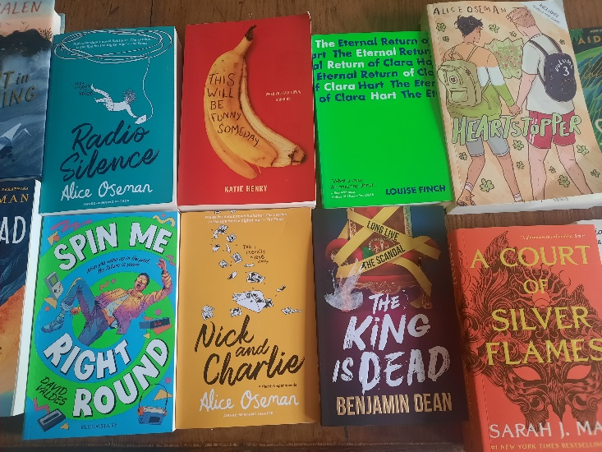 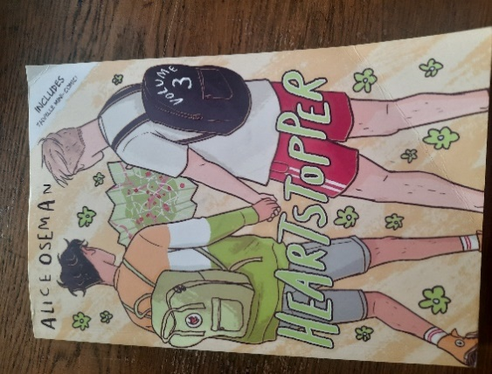

An exciting time for the library, as we continue to develop the space and add the finishing touches to our ‘Chill Out Area’. We have purchased a sensory lamp and room dividers to make the space even more relaxing.

A huge ‘thank you’ to The Parents’ Association who have been very generous and have always supported the school library.

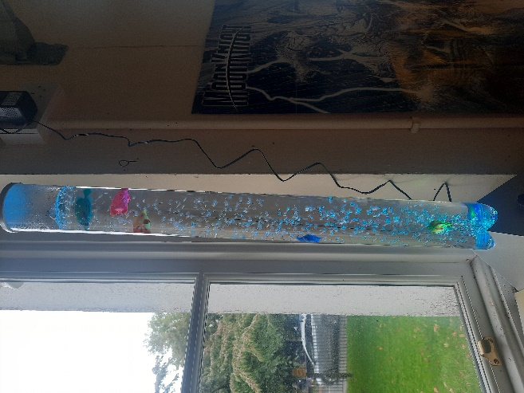

Our new sensory fish lamp